|  |  |  |
| --- | --- | --- |
| **LAB221 Assignment** | **Type:** | **Short Assignment** |
| **Code:** | **J2.S.P0106** |
| **LOC:** | **40** |
| **Slot(s):** | **1** |

**Title**

Transfer data between parent dialog and child dialog.

**Background Context**

In fact, data transferring between parent dialog and child dialog always occur, sometime we need to transfer data from parent dialog to child dialog, and sometime we need to transfer data from child dialog to parent dialog

**Program Specifications**

Create a program to simulate transferring data between parent form and child form.

***Function details:***

* Parent dialog contains list of stocks
* Child dialog displays stock detail selected from the list in the parent dialog

***Expectation of User interface:***

The screen when the program startup should be as:

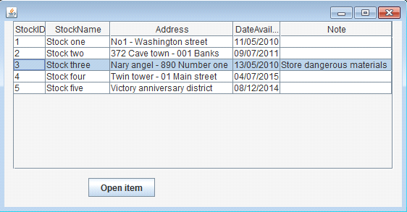

* Select item has StockID = 3, click “Open item” button: child dialog displays detail information of stock 3

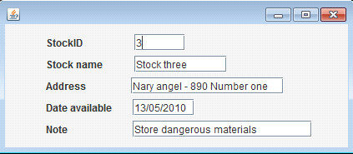

**Guidelines**

* Using your own data